**CIS017-1 / CIS095-1**

**MySQL Workshop using the Command Line Interface (CLI)**

This is to show you how you can run MySQL commands from the Console or Command Line Interface (CLI).

To carry out this exercise you have a few alternatives:

1. You use a PC with **MySQL** client (at least) installed

**MySQL** **Community** **Server** can be downloaded free from <https://dev.mysql.com/downloads/>

You will need to set up an Oracle account.

You will also need to set the PC’s **PATH** under **Environment Variables** to the location of the file **MySQL**.**exe**. This shows the PC where to find the file at Start Up.

In my case the PATH is: **C:\Program Files\MySQL\MySQL Server 8.0\bin**

1. Alternatively, download and install **WAMPServer** and use **WAMP’s MySQL Console**.  
   Download **WAMPServer**: <https://sourceforge.net/projects/wampserver/>

We are going to create a database called **LeeOfficeSupplies**

|  |  |  |  |  |
| --- | --- | --- | --- | --- |
| **Database: LeeOfficeSupplies**  **Table: StockItems** | | | | |
| **ItemCode** | **ItemDesc** | **ItemStockQty** | **ItemUnitPrice** | **ItemCategory** |
| **LOS001** | **A4 paper x 500 sheets (white)** | **100** | **3.50** | **Paper** |
| **LOS002** | **A4 paper x 500 sheets (blue)** | **205** | **3.70** | **Paper** |
| **LOS003** | **A4 paper x 500 sheets (yellow)** | **300** | **3.70** | **Paper** |
| **LOS004** | **Ballpoint pen x 40 (red ink)** | **30** | **10.00** | **Pens** |
| **LOS005** | **Ballpoint pen x 40 (red ink)** | **40** | **10.00** | **Pens** |
| **LOS006** | **Ballpoint pen x 40 (red ink)** | **20** | **10.00** | **Pens** |
| **LOS007** | **Pencil eraser x 50** | **10** | **10.00** | **Eraser** |

I have just installed **MySQL** **Community** **Server 8.0** on my PC…..

I have also set up the **PATH** **Environment Variable**

Please note: Some of this is very fiddly and frustrating to set up on a PC, and for the purposes of learning MySQL it may be easier just to use **WAMPServer**.

I have two option:

1. Select **Start -> MYSQL 8.0 Command Line Client**

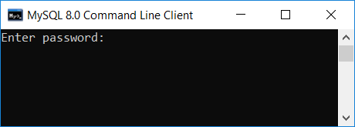

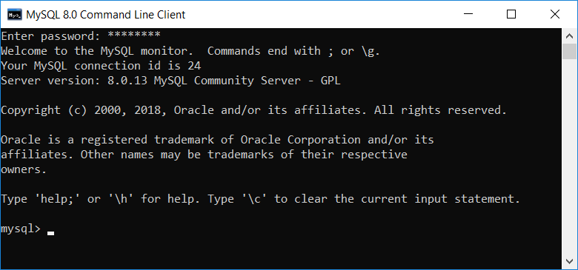

1. Select **Start** and enter **cmd**

Enter:

**mysql –h localhost:3309 –u root -p**

**Note**: I changed the Port No for MySQL on installation to 3309 since the default Port was already in use.

At prompt, enter the password set up on installation of **MySQL** **Server 8.0**

**Note**: If you were doing this at the University and want to access the University’s **MySQL** database, you would enter:

**mysql – h studentnet.cst.beds.ac.uk –u XXXXX -p**

You would then be prompted to enter your password XXXXX

Where XXXXX is your University ID.

In fact, in the following exercise I accessed WAMP (!) – without realising it until later - which was the default MySQL installation on this PC. This explains why a password was not required!

However, the principles and SQL commands are the same…

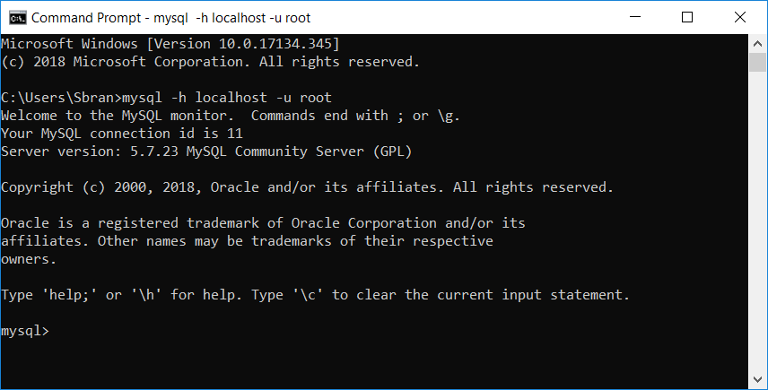

Enter **CREATE DATABASE LeeOfficeSupplies;**

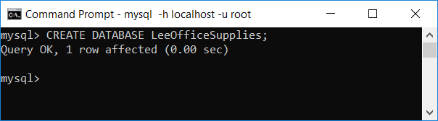

Enter **USE LeeOfficeSupplies;**

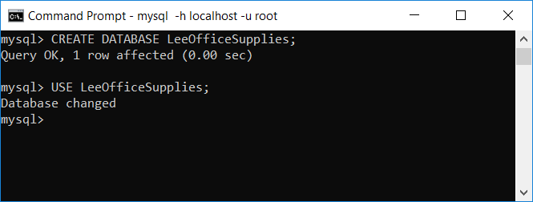

To create the **StockItems** table it is necessary to provide the definition (or structure) of the table. This is achieved by specifying the **field** **names**, **field** **types** and **field** **sizes**.

We can also identify whether fields can be **null** (have no contents) and which field is to be set as the **primary** **key** (has **unique** values).

Simple data types are used – **varchar** is for strings of characters, **int** for integers, and **decimal** for numbers with decimal places.

Further information on **MySQL** datatypes can be found at:

<http://dev.mysql.com/doc/refman/5.5/en/data-types.html>

Here is the suggested definition for the **StockItems** table:

|  |  |  |  |  |
| --- | --- | --- | --- | --- |
| **Field Name** | **Field Type** | **Field Size** | **Can be Null?** | **Primary Key** |
| **ItemCode** | **varchar** | **6** | **No** | **Yes** |
| **ItemDesc** | **varchar** | **40** | **Yes** |  |
| **ItemStockQty** | **int** | **11** | **No** |  |
| **ItemUnitPrice** | **decimal** | **7 digits including 2 decimal places** | **No** |  |
| **ItemCategory** | **varchar** | **20** | **No** |  |

To create the table, enter the following very carefully at the **mysql** prompt:

**CREATE TABLE StockItems (ItemCode varchar(6) NOT NULL, ItemDesc varchar(40) NULL, ItemStockQty int NOT NULL, ItemUnitPrice decimal(7, 2) NOT NULL, ItemCategory varchar(20) NOT NULL, PRIMARY KEY(ItemCode));**

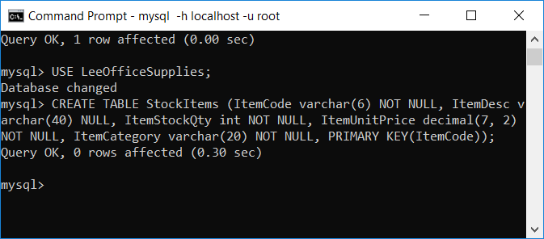

It is common to make keying errors at this point, and **MySQL** will respond with an error message. Previous **MySQL** commands are accessible via a command history. Simply use the **up** and **down** **cursor** keys to access a previous command in order to edit it. Then press **Enter** again.

At the **mysql** prompt, enter:

**SHOW TABLES;**

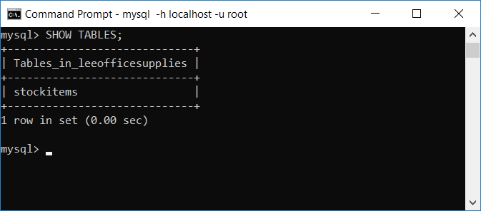

It is possible to view a table’s definition (or structure):

At the **mysql** prompt, enter

**DESCRIBE StockItems;**

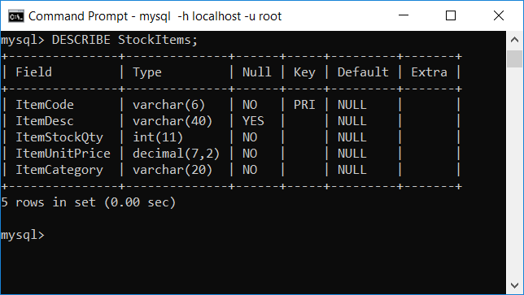

The command **EXPLAIN** can be used instead of **DESCRIBE**.

At the **mysql** prompt, enter

**EXPLAIN StockItems;**

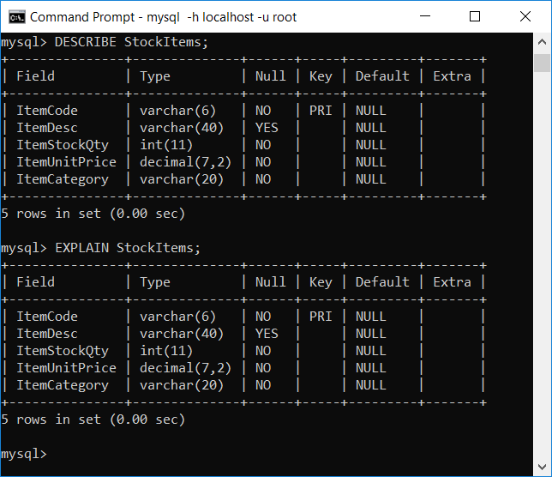

Populating the **StockItems** table can be achieved in a number of ways. Perhaps the simplest technique is to use the **MySQL** **INSERT** statement. This is, however, quite time-consuming and, in practice, tables may be created and populated by executing a separate **.SQL** file (containing the required commands) at the command line interface.

**Note**: You can execute an **SQL** script file using the **source** command or **\.** command:

**mysql> source file_name**

**mysql> \. file_name**

At the **mysql** prompt, enter

**INSERT INTO StockItems VALUES("LOS001** **", "A4 Paper x 500 sheets (white)** **", 100, 3.50, "Paper** **");**

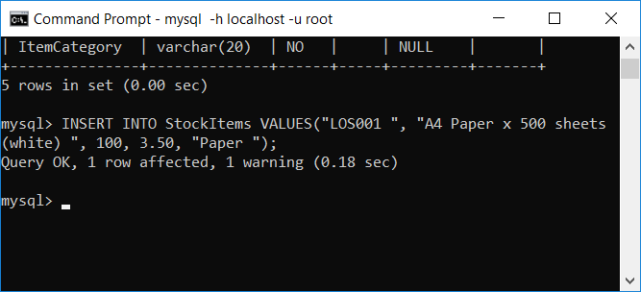

The **SELECT** statement is one of the most frequently used statements. It is used to query the database and produce a **results** **set** which is returned to the client.

At the **mysql** prompt, enter

**SELECT * FROM StockItems;**

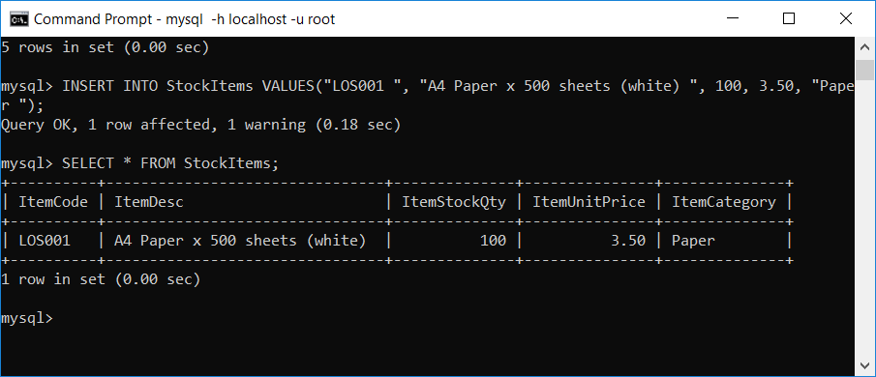

This statement selects all rows and all fields (specified with the **\*** symbol) from the table.

Repeat the instructions above to insert the remaining rows into the **StockItems** table.

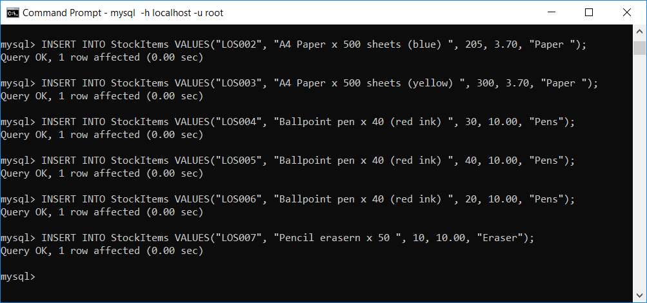

Next, repeat the above **SELECT** query to display all **7** rows in the **StockItems** table:

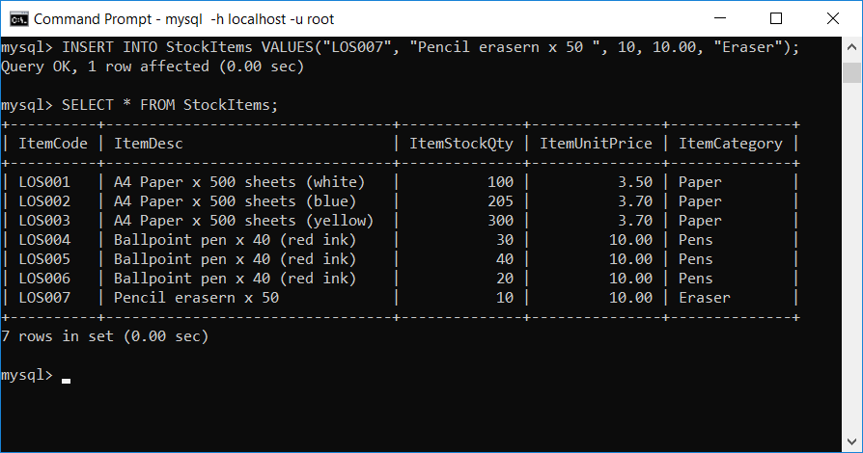

You can now practice a range of SQL commands on this table.

In addition, you could create a new table **Users**:

|  |  |  |  |  |  |
| --- | --- | --- | --- | --- | --- |
| **Database: LeeOfficeSupplies**  **Table: Users** | | | | | |
| **UserID** | **FirstName** | **LastName** | **Username** | **Password** | **Email** |
| **UID001** | **Helen** | **Troy** | **HelenT** | **Planet10** | **HT@somewhere.com** |
| **UID002** | **Shekhar** | **Chopra** | **ShekharC** | **123Water** | **SC@myplace.co.uk** |
| **UID003** | **Mark** | **Beach** | **MBeach** | **MB9999** | **Mark@Beachy.com** |

Here is the suggested definition for the **Users** table:

|  |  |  |  |  |
| --- | --- | --- | --- | --- |
| **Field Name** | **Field Type** | **Field Size** | **Can be Null?** | **Primary Key** |
| **UserID** | **varchar** | **6** | **No** | **Yes** |
| **FirstName** | **varchar** | **20** | **Yes** |  |
| **LastName** | **varchar** | **20** | **Yes** |  |
| **Username** | **varchar** | **10** | **No** |  |
| **Password** | **varchar** | **10** | **No** |  |
| **Email** | **varchar** | **20** | **No** |  |

To create the table, enter the following very carefully at the **mysql** prompt:

**CREATE TABLE Users (UserID varchar(6) NOT NULL, FirstName varchar(20), LastName varchar(20), Username varchar(10) NOT NULL,** **Password varchar(10) NOT NULL, Email varchar(20) NOT NULL, PRIMARY KEY(UserID));**

To insert records, enter:

**INSERT INTO Users VALUES("UID001", "Helen", "Troy", "HelenT", "Planet10", "HT@somewhere.com");**

Press the **Return** key:

**INSERT INTO Users VALUES("UID002", "Shekhar", "Chopra", "ShekharC", "123Water", "SC@myplace.co.uk");**

Press the **Return** key:

**INSERT INTO Users VALUES("UID003", "Mark", "Beach", "MBeach", "MB9999", "Mark@Beachy.com");**

Press the **Return** key:

**Using WAMPServer**

Select **Start -> WAMPSERVER**

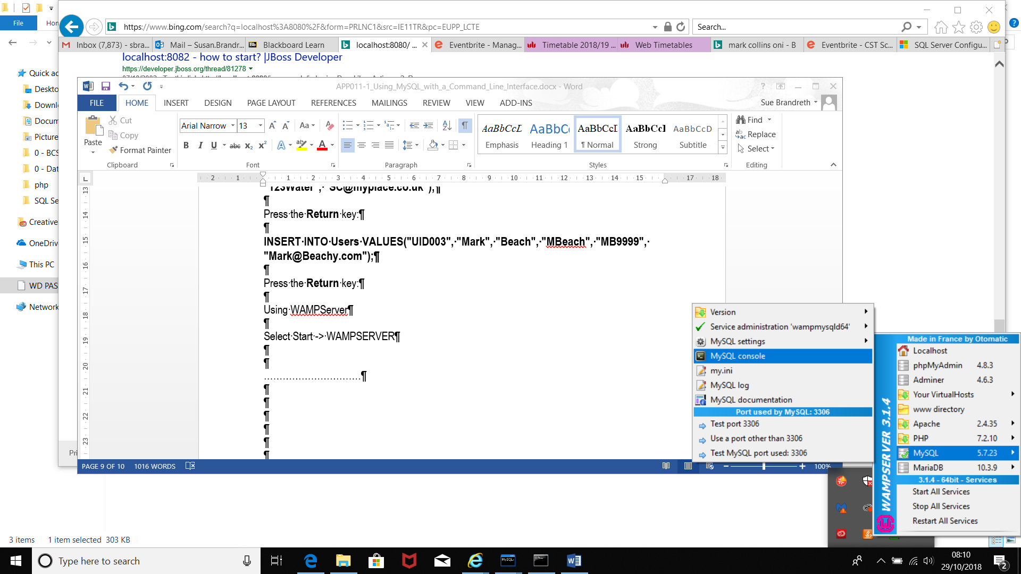

Select the **WAMP** icon on the bottom right of the screen.

Select **MySQL -> MySQL console**

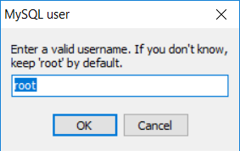

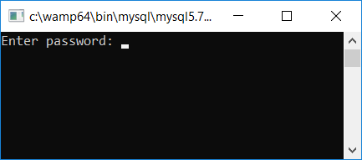

Just press Enter

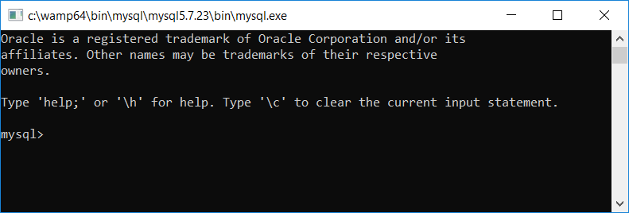

You can now start using **WAMP MySQL** as before by entering the MySQL commands directly.

(But this time you are definitely using WAMP MySQL!)